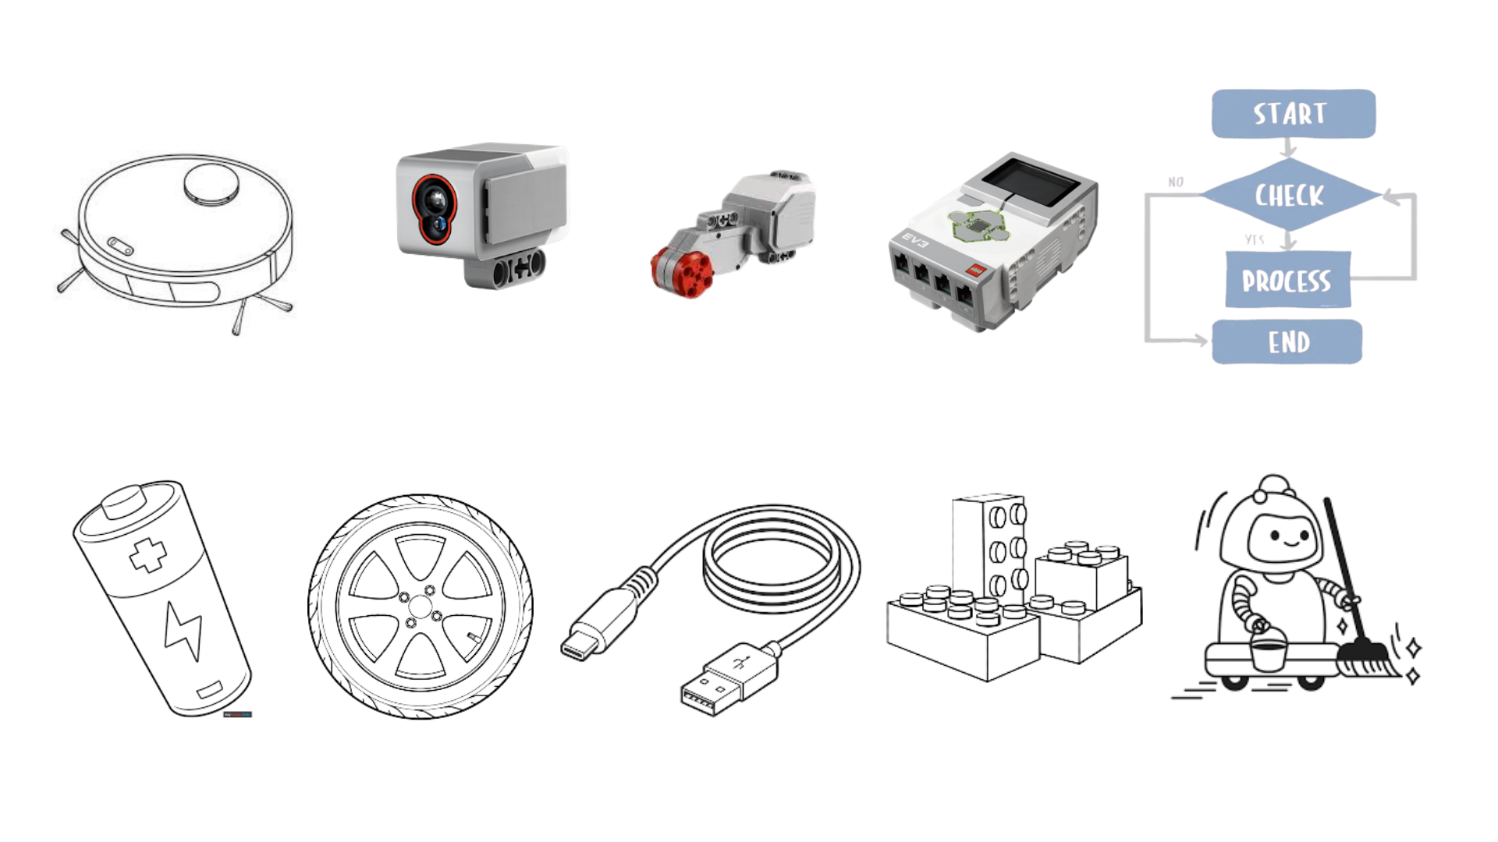
ACADEMIA INTERNACIONAL DE DAVID


TECHNOLOGY 3rd Grade
SUMMATIVE ACTIVITY # 1

- A machine that can do tasks automatically:____________________________________________.
- A round part that helps a robot move:____________________________________________.
- A set of instructions that tells a robot what to do:__________________________________.
- A wire used to connect the robot to the PC:_______________________________________.
- A job or action that a robot performs: ____________________________________________.
- A part that makes the robot move:____________________________________________.
- The part that gives power or energy to the robot :__________________________________.
- The different parts used to build or assemble a robot: :______________________________.
- The brain of the robot:____________________________________________.
- A part that helps a robot detect things:______________________________________
Instructions: Complete this workshop using only a pencil or a pen. Do not use liquid paper or any permanent corrector.
Instructions PT.I
- Color each image using the color indicated by the teacher. 1pt each
- Write the correct vocabulary word under or over each picture. 1pt each
Instructions PT.II
- Write the correct name of the correct image next to each definition. 1pt each
Criteria
Follows instructions: 4 points
Order: 3 pts
Date (properly written): 1pt
Correct use of tools: 2pts

